Hemispherical Cap
# Source: AI Source: Provided by: [Data Path: Persons Table -> ID Column: 1, Name_En Column: Motasem Essam] -> From: [ChatGPT] on [7/25/2026]
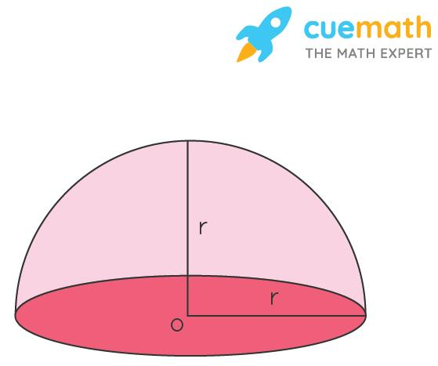
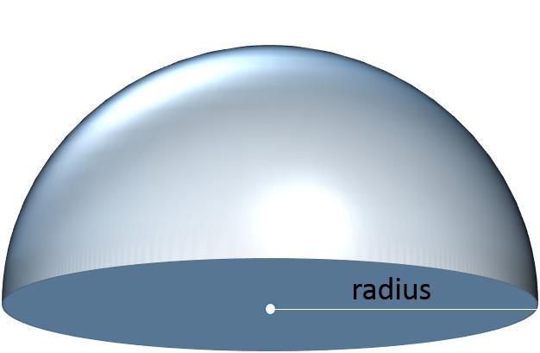
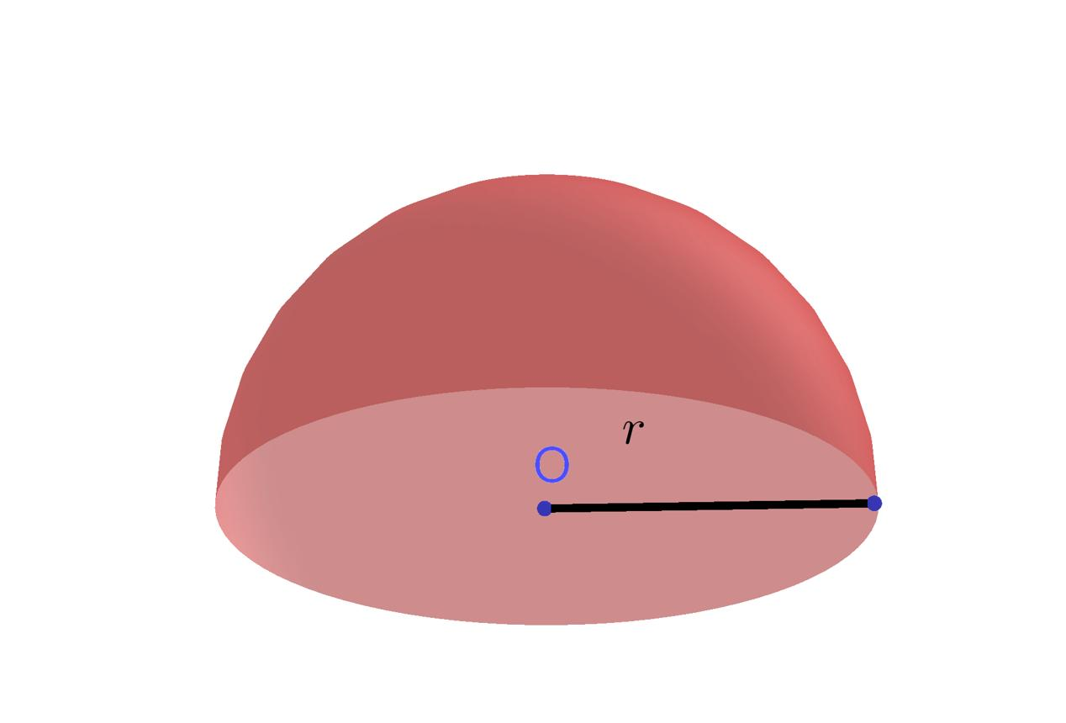

Definition
# Source: AI Source: Provided by: [Data Path: Persons Table -> ID Column: 1, Name_En Column: Motasem Essam] -> From: [ChatGPT] on [7/25/2026]
A hemispherical cap is a spherical cap whose cutting plane passes through the center of a sphere, dividing it into two equal halves. It is a hemisphere: one half of a solid sphere, bounded by a curved hemispherical surface and a flat circular base.
A hemispherical cap is the special case of a spherical cap in which the cap height equals the sphere radius.
$$\boxed{h=R}$$
Terminology note: Hemisphere is the standard geometric name for this solid. Hemispherical cap emphasizes that it is obtained by cutting a sphere through its center.

Simple Definition
# Source: AI Source: Provided by: [Data Path: Persons Table -> ID Column: 1, Name_En Column: Motasem Essam] -> From: [ChatGPT] on [7/25/2026]
A hemispherical cap is half of a solid sphere, like a ball cut exactly through its middle.
Examples include a half-sphere dome, a hemispherical bowl shape, or a solid half-ball.

Geometric Structure
# Source: AI Source: Provided by: [Data Path: Persons Table -> ID Column: 1, Name_En Column: Motasem Essam] -> From: [ChatGPT] on [7/25/2026]
The main geometric elements are:
- Sphere center $O$: The center of the original sphere and the center of the circular base plane.
- Radius $R$: The distance from the sphere center to any point on the curved surface.
- Cutting plane: A plane passing through the sphere’s center.
- Circular base: The flat disk created by the cut.
- Base radius $r$: Equal to the sphere radius $R$.
- Base diameter $D$: Equal to $2R$.
- Height $h$: The perpendicular distance from the base plane to the top of the hemisphere; equal to $R$.
- Curved surface: Half of the sphere’s outer surface.

Mathematical Representation
# Source: AI Source: Provided by: [Data Path: Persons Table -> ID Column: 1, Name_En Column: Motasem Essam] -> From: [ChatGPT] on [7/25/2026]
Consider a sphere centered at the origin with radius $R$:
$$x^{2}+y^{2}+z^{2}=R^{2}$$
Cut the sphere through its center using the plane
$$z=0$$
The upper hemisphere is described by
$$x^{2}+y^{2}+z^{2}≤R^{2}, z≥0$$
The lower hemisphere is described by the same sphere inequality with $z≤0$.
For either hemisphere, the height and base radius satisfy
$$\boxed{h=R, r=R}$$
The two hemispheres have equal volumes and equal curved surface areas.

Important Formulas
# Source: AI Source: Provided by: [Data Path: Persons Table -> ID Column: 1, Name_En Column: Motasem Essam] -> From: [ChatGPT] on [7/25/2026]
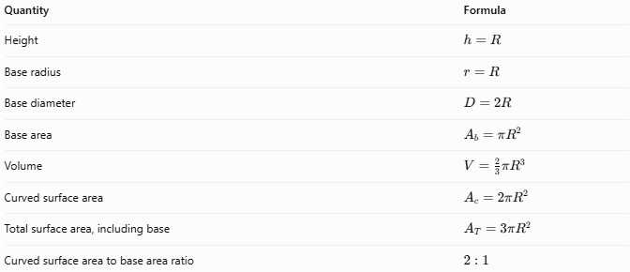
Quantity | Formula
Height | $$h=R$$
Base radius | $$r=R$$
Base diameter | $$D=2R$$
Base area | $$A_{b}=πR^{2}$$
Volume | $$V=\frac{2}{3}πR^{3}$$
Curved surface area | $$A_{c}=2πR^{2}$$
Total surface area, including base | $$A_{T}=3πR^{2}$$
Curved surface area to base area ratio | $$2:1$$
Important: The curved surface area excludes the flat base. The total surface area includes the curved surface and the circular base.

Worked Example
# Source: AI Source: Provided by: [Data Path: Persons Table -> ID Column: 1, Name_En Column: Motasem Essam] -> From: [ChatGPT] on [7/25/2026]
A solid hemisphere has a radius of $6\text{ cm}$. Calculate its volume, curved surface area, and total surface area.
Step 1 — Volume
$$V=\frac{2}{3}πR^{3}$$
$$V=\frac{2}{3}π{\left(6\right)}^{3}=144π$$
$$\boxed{V≈452.39{\text{ cm}}^{3}}$$
Step 2 — Curved surface area
$$A_{c}=2πR^{2}$$
$$A_{c}=2π{\left(6\right)}^{2}=72π$$
$$\boxed{A_{c}≈226.19{\text{ cm}}^{2}}$$
Step 3 — Total surface area
Add the flat circular base area:
$$A_{T}=3πR^{2}$$
$$A_{T}=3π{\left(6\right)}^{2}=108π$$
$$\boxed{A_{T}≈339.29{\text{ cm}}^{2}}$$
Conclusion: The hemisphere has a volume of approximately $452.39{\text{ cm}}^{3}$, a curved surface area of $226.19{\text{ cm}}^{2}$, and a total surface area of $339.29{\text{ cm}}^{2}$.

Comparison with Related Shapes
# Source: AI Source: Provided by: [Data Path: Persons Table -> ID Column: 1, Name_En Column: Motasem Essam] -> From: [ChatGPT] on [7/25/2026]
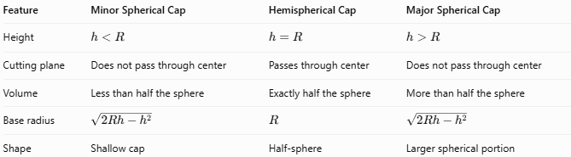
Feature | Minor Spherical Cap | Hemispherical Cap | Major Spherical Cap
Height | $$h<R$$ | $$h=R$$ | $$h>R$$
Cutting plane | Does not pass through center | Passes through center | Does not pass through center
Volume | Less than half the sphere | Exactly half the sphere | More than half the sphere
Base radius | $$\sqrt{2Rh-h^{2}}$$ | $$R$$ | $$\sqrt{2Rh-h^{2}}$$
Shape | Shallow cap | Half-sphere | Larger spherical portion

Applications
# Source: AI Source: Provided by: [Data Path: Persons Table -> ID Column: 1, Name_En Column: Motasem Essam] -> From: [ChatGPT] on [7/25/2026]
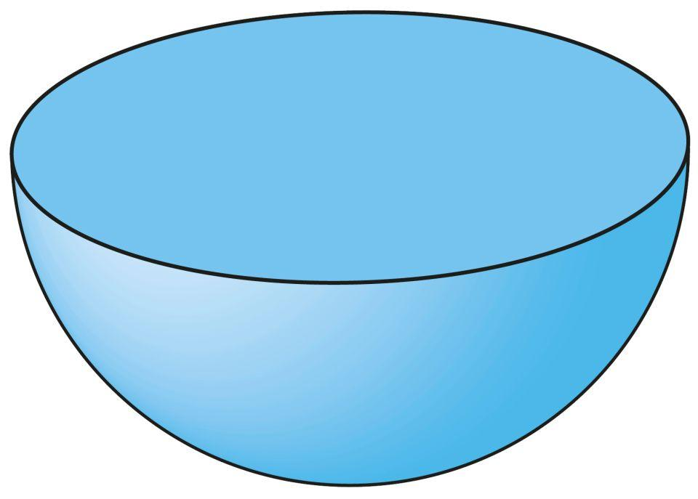
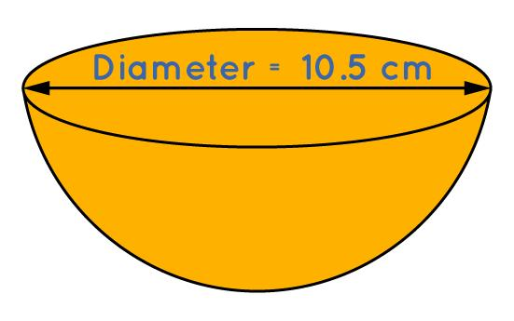
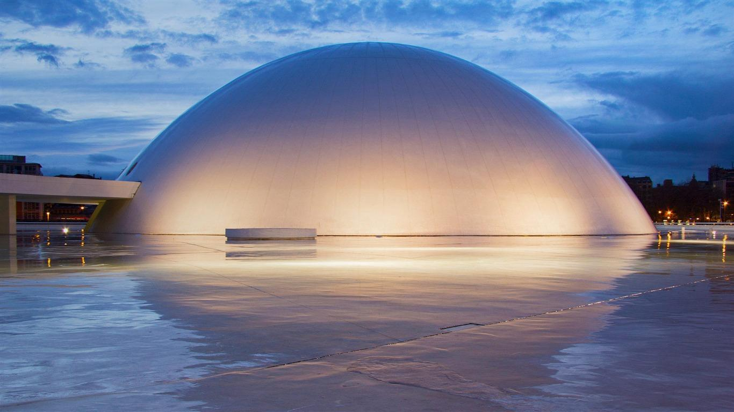
Hemispherical shapes are used in:
- Architecture: Domes and rounded roofs.
- Manufacturing: Half-spherical components and molds.
- Containers: Hemispherical bowls and vessels.
- Engineering: Tank ends, pressure-vessel components, and structural models.
- Mathematics: Studying sphere volume, surface area, and symmetry.

Key Points
# Source: AI Source: Provided by: [Data Path: Persons Table -> ID Column: 1, Name_En Column: Motasem Essam] -> From: [ChatGPT] on [7/25/2026]
- A hemispherical cap is half of a solid sphere.
- Its cutting plane passes through the sphere’s center.
- Its height and base radius both equal $R$.
- Its volume is half the volume of the original sphere.
- Its curved surface area is $2πR^{2}$.
- Its total surface area, including the base, is $3πR^{2}$.
- The two hemispheres produced by a central cut are equal in volume and surface area.

Conclusion
# Source: AI Source: Provided by: [Data Path: Persons Table -> ID Column: 1, Name_En Column: Motasem Essam] -> From: [ChatGPT] on [7/25/2026]
A hemispherical cap is the special spherical cap formed when a sphere is cut through its center. It has a height equal to its radius, a circular base with radius $R$, and exactly half the volume of the original sphere. It is commonly called a hemisphere and is important in geometry, architecture, and engineering.

